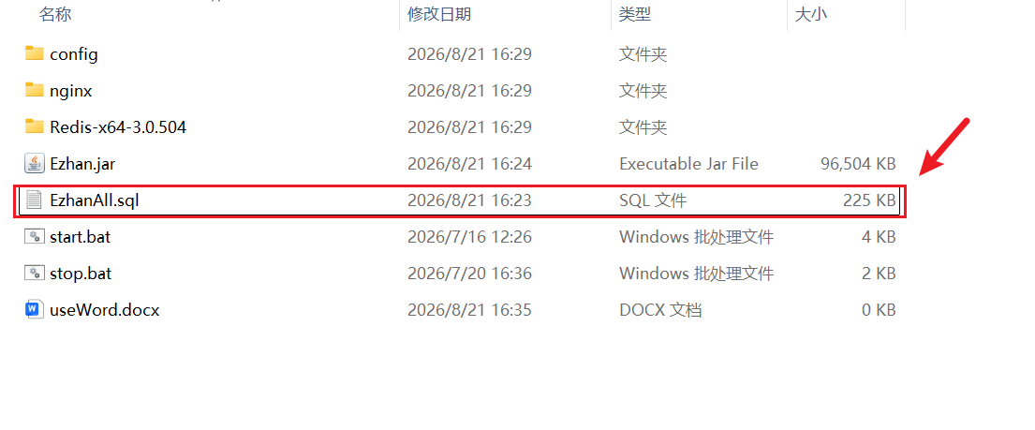
The difference between the startup method of this software package and the previous one lies in the fact that you need to add another database and name it "Ezhant". Then, you should re-run the EzhanAll.sql file in this folder and copy the authorization code to the authorization code file in the config folder of this folder as well.

